 |  | China Health (HK) Consultancy Ltd.  華健（香港）顧問有限公司

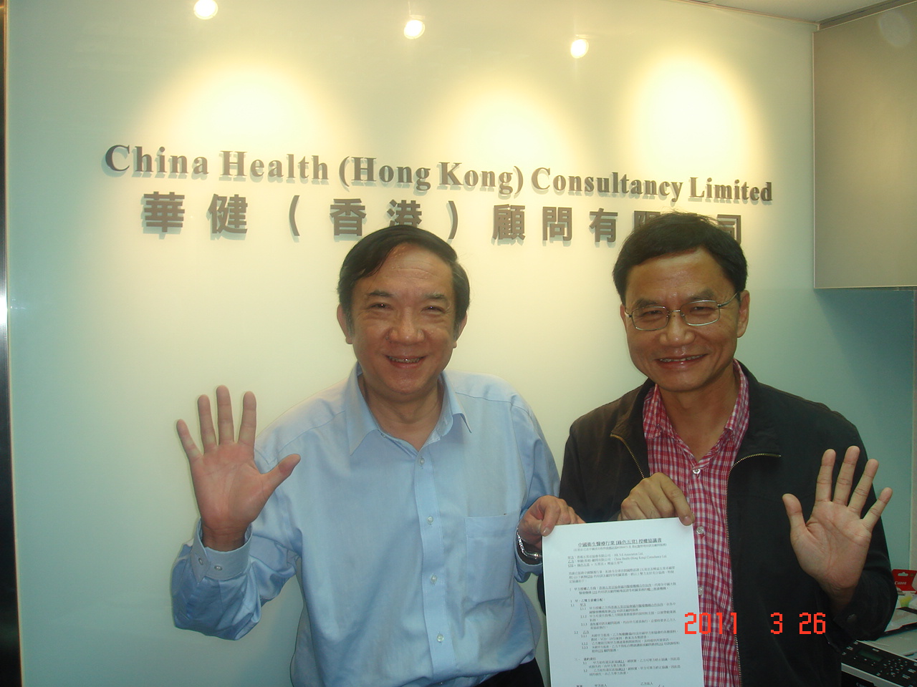

龐可榮醫生 與 何廣明教授 簽署合作協意書

全球首創：醫護 五常法

自2000年，香港公立醫院在何兆煒醫生(當時醫院管理局行政總裁)領導及香港五常法協會的大力推動下，成功在45間公立醫院實施了五常法(佔全港入院人數90%以上)。五常法包括了：常組織、常整頓、常清潔、常規範和常自律，是一種能協助機構建立持續改善及維持良好品質環境的技術。五常法能迅速及有效地改善安全（S）、衛生（H）、品質（Q）、效率（P）、形象（I）及提升競爭力，而高層至前線員工皆能執行，所以是全面品質管理的第一步。

日文5S | 英文 5-S * | 五常法 * | 共50點 * | 審核表(共50點) * < * 何廣明 教授創>
Seiri | Structurise | 常組織 | 10 | 拋掉不需要的東西或回倉和制定工作計畫表
Seiton | Systematise | 常整頓 | 10 | 所有用具物品都予以名稱和位置，30秒內找到
Seiso | Sanitise | 常清潔 | 5 | 個人清潔責任的劃分，環境清潔齊整明亮照人
Seiketsu | Standardise | 常規範 | 15 | 貯藏的透明度、防止食物變壞和避免出錯方法
Shitsuke | Self-discipline | 常自律 | 10 | 履行個人職責、確保優良環境、問責和守時等

香港五常法協會協助在香港的醫院推動五常法包括:
醫院管理局總部及其下45間公立醫院、特別是瑪麗醫院、伊利莎白醫院、瑪嘉烈醫院、廣華醫院、仁濟醫院、屯門醫院、雅麗氏何妙齡娜打素醫院、葛量洪醫院、聖母醫院、明愛醫院、靈實醫院、專科醫療保健中心、廣東省第一人民醫院、龍崗市人民醫院、温州市人民醫院等。

值得一提的是瑪嘉烈醫院為全港第三大的醫院，設有1,200張病床及3,500名員工。於2002年，考獲由香港五常法協會所建立的五常法認證服務，成為全球首間五常法認證的醫院。於2002年12月4日，十二位香港五常法協會的審核師前往審核10幢瑪嘉烈醫院的建築物。當中發現了只有兩個不及格點和數個觀察點。 以下是實行了五常法後的改善記錄:
  - 安全 – 事故率下降15%
  - 衛生 – 交叉感染由31個案件下降到16個案件
  - 品質 – 臨床錯誤下降20%
  - 效率 – 每年節省人力成本美金1.56百萬
  - 形象 – 病人滿意度改善，由 73% 升至 80%

現在，對於所有香港公立醫院而言，五常法是他們文化和日常工作中一個重要組成部分。另外，五常法是一個非常有效的工具去減少醫療錯誤。在2009年1月16日，我於九龍中聯網的醫療會議上，與200多名醫療衛生專業人員，分享了一次主題為《通過五常法，減少醫療風險》的演講。我用了10個例子，向他們展示了五常法能如何減少醫療錯誤，獲得全場掌聲及認同。

如需進一步查詢，請聯絡我們的高級顧問 － 蔡靜兒小姐（M: +852-6532-2636）或本人。

祝商祺。

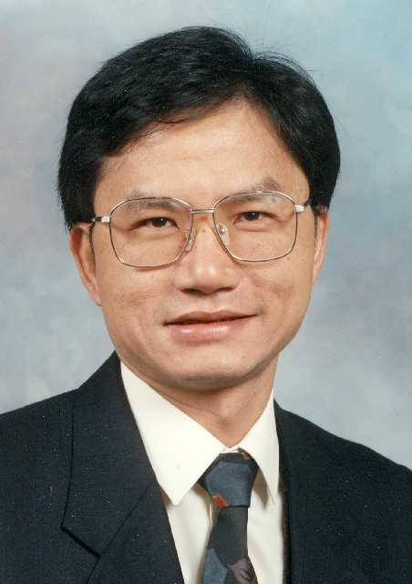
何廣明教授 PhD(Mgt.), FIQA, EQA Assessor, 手電：+852-9128-9204, samho@hk5sa.com
    - 亞洲生產力組織押川研究員 (86-87)
    - 馬來西亞政府亞洲發展銀行品質專家 (93-94)
    - 第一屆至第十五屆“ISO和全面優質管理國際會議 – ICIT”主席 (96-11)
    - 英國魯頓商學院策略及品管講座教授(96-97)
    - 英國劍橋大學Judge管理學院研究員(96-97)
    - 英國牛津大學Said商學院客席講師
    - 英國國際管理學院策略及品管教授
    - 分別于英國高雲地利/佩斯利大學、澳洲皇家理工大學及瑞典Vaxio出任客席教授
    - 中國廣州中山大學首位卓越企業管理桂冠教授
    - 曾向過千間機構提供ISO9000和五常法顧問及培訓服務
    - 香港五常法協會創會主席 - 擁有超過二萬會員和過千家認證企業
    - 著有100多份論文和20本書籍，其中包括 "TQM: Integrated Approach"，翻譯為五種語言

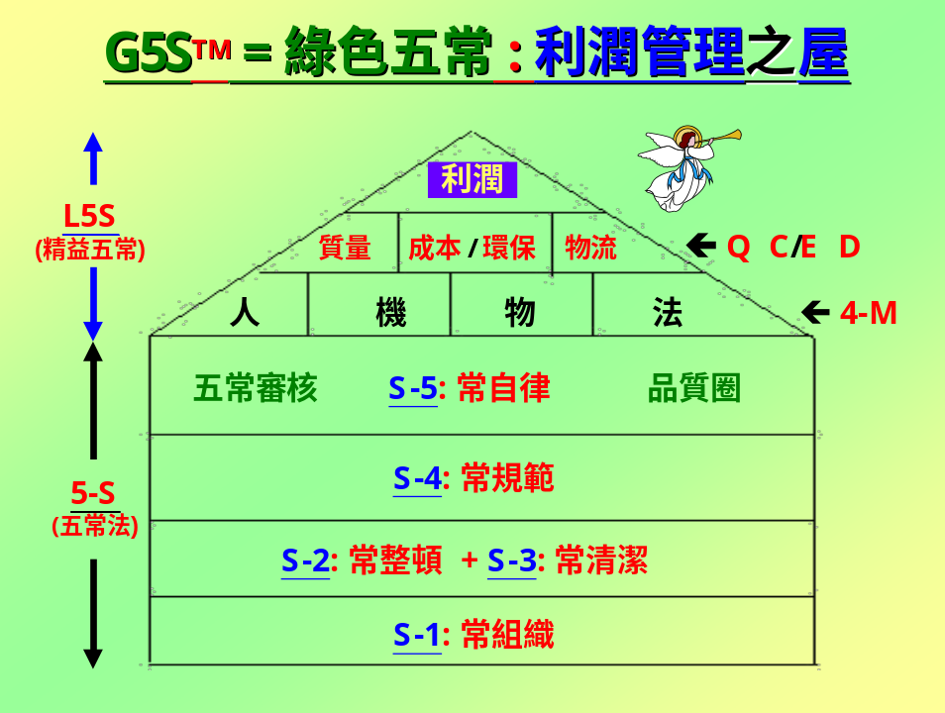
The HK5SA-G5S Model for Hospital Operations

G5S* = 5-S* + L5S* ➔ (ISO 9000 / 14001 / 50000 + OH 18001 + JCI/ACHS) ➔ APBEST*
* Developed by Prof. Sam Ho

5-S = Structurise, Systematise, Sanitise, Standardise & Self-discipline [ www.hk5sa.com ]
L5S = Lean 5-S Model [ www.hk5sa.com ]
ISO 9001 = Quality Management System [ www.iso.org ]
ISO 14001 = Environmental Management System [ www.iso.org ]
ISO 50001 = Energy Management System [ www.iso.org ]
OH 18001 = Occupational Health & Safety Management System [ www.ohsas.org ]
JCI = Joint Commission International [ www.jointcommissioninternational.org ]
ACHS = Australian Council on Healthcare Standard [ www.achs.org.au ]
APBEST = Asia-Pacific Business Excellence Standard Award [ www.apbest.org ]

附件：

- 香港醫護五常法運動－節錄自《醫護五常法手冊》
- 瑪嘉烈醫院於2002年，成為全球首間五常法認證的醫院
- 全香港第二大的醫院屯門醫院，於2003年推行五常法
- 全香港最大的醫院伊利沙伯醫院，於2004-2010推行五常法、精益五常及於2010年榮獲亞太企業標準大獎

App. 1: Past Experience from the Founder Chair (Prof. Sam Ho)

– HK 5-S Campaign for Hospitals

In order to promote the 5-S practice in Hong Kong, it is important that a massive promotional campaign be launched together with an easily accessible training programme. In 1998, the HKSAR Government approved a US$0.6 million training programme for training up 2,500 people in two years’ time as 5-S Lead Auditors, the first of its kind in the world. Since launched in April 98, over 10,000 Lead Auditors had been trained, including a number of in-company training for the manufacturing, construction, service, health, education and public sectors. In 1999, the HK 5-S Association was established in order to continue promote the HK 5-S Campaign beyond the end of the funded project, with the world’s first 5-S Annual Convention held in May 99. Moreover, the training programme was franchised to the HK Civil Service Training and Development Institute, Hospital Authority, DHL, and some statutory organisations in China. Since 2000, a 5-S organization certification scheme, with over 500 organisations, totaling over 45,000 employees in the HKSAR and China are working under the 5-S Registered Firms.

In 1999, Dr. William Ho, the Chief Executive of the Kwong Wah Hospital which is one of the largest hospitals in HK with over 3,000 employees and 1,000 beds, decided to launch a 5-S campaign under the guidance of Prof. Sam Ho. Within 6 months, the hospital saw a significant improvement in safety, hygiene, quality, productivity and image. In 2000, Dr. Ho was promoted to the Chief Executive of the Hospital Authority (HA) looking after 45 public hospitals with a total workforce of 54,000. In 2000, the HA launched a pan-HA 5-S campaign involving literally all of the 45 hospitals. Two 5-S Conventions were launched at the HA headquarters during 2000 & 2001, and Prof. Sam Ho was invited as keynote speaker:
  - "1st Hospital 5-S Convention" at the Hospital Authority Headquarters, opening speech by Dr. William Ho, the CE of HA. on 4 Mar 00, attended by over 300 delegates from 40 hospitals. Three hospitals (Kwong Wah, Princess Margaret, Taipo Nethersole) presented their cases.
  - "2nd Hospital 5-S Convention" at the Hospital Authority Headquarters, opening speech by Dr. Lawrence Lai, the DD (Corporate Affairs) of HA. on 16 June 01, attended by over 400 delegates from 40 hospitals. 10 hospitals presented their cases.

Furthermore, there are many hospitals inviting Prof. Ho to be the Keynote Speaker and Chief Examiner for their in-house 5-S conventions and competitions. Examples are:
- Keynote Speaker on "5-S for Hospital Operations -- An Effective Tool to avoid Errors" organised by the Princess Margaret Hospital on 22 Sep 98, and attended by over 200 nurses, doctors and administrators.
- Keynote Speaker on "5-S Practice for Hospital Operations" in the Continuous Quality Improvement Seminar attended by over 300 delegates from the Institute of Advanced Nursing Studies, Hospital Authority on 13 Jan 99 at HA Headquarters, HK.
- Keynote Speaker on "Business Process Re-engineering for Hospital Operations", attended by over 100 doctors, nurses and administrators of the Kwong Wah Hospital (KWH) on 3 Feb 99 at the KWH, HK.
- Keynote Speaker on "5-S Practice for Hospital Operations" at the Yan Chai Hospital on 3 Nov 99 attended by around 180 medical, nursing and administrative staff.
- Keynote Speaker on "5-S Practice for Hospital Operations" at the College of Nursing on 8 Dec 99, to be attended by 100 delegates.
- Keynote Speaker on "5-S Practice for Hospital Operations" at the Caritas Medical Centre on 20 Dec 99, attended by 200 delegates.
- Chief Examiner on “Hospital 5-S Competition”, at the Prince of Wales Hospital on 5 Dec 2000.
- Chief Examiner on “Hospital 5-S Competition”, at the Tuen Mun Hospital on 6 Mar 2001, attended by around 200 medical/nursing and admin. staff.
- Chief Examiner on “Hospital 5-S Competition”, at the Caritas Hospital on 13 Mar 2001, attended by around 250 medical/nursing and admin. staff.
- Chief Examiner on “Hospital 5-S Presentation”, at the Princess Margaret Hospital on 12 Oct 2001, attended by around 200 medical/nursing and admin. staff.
- Keynote Speaker on “Hospital 5-S Practice”, at the Queen Elizabeth Hospital on 20 Oct 2001, attended by around 150 medical/nursing and admin. staff.
- Chief Examiner on “Hospital NT-W Cluster 5-S Competition”, at the Tuen Mun Hospital on 14 Mar 2003, attended by around 200 medical/nursing and admin. staff.
- Keynote Speaker on “Hospital 5-S Practice”, at the Shatin Hospital on 17 May 2004, attended by around 100 medical/nursing and admin. staff.
- Keynote Speaker on “5-S Quality Management in Hospital Operations”, at the Faculty of Medicine, HKU on 18 Jun 2004, attended by around 150 medical graduate students during the Pre-internship Block.
- Keynote Speaker on “5-S Quality Management in Hospital Operations”, at the College of Nursing, HKU on 15 Jun 05, attended by around 150 nursing graduate students during the Pre-internship Block.
- Chief Examiner on “Hospital 5-S Competition”, for the NT East Cluster of hospitals, at the Prince of Wales Hospital on 8 Mar 2007, attended by around 250 medical/nursing and admin. staff.
- Chief Examiner on “Hospital 5-S Competition”, for the Kowloon Central Cluster of hospitals, at the Queen Elizabeth Hospital on 24 Aug 2007, attended by around 200 medical/nursing and admin. staff.
- Keynote Speaker on “5-S enhanced ISO 22000 Food Safety Management System”, 3rd Food Safety Management Forum, HK Food Science & Technology Association on 8 Dec 2007, attended by around 100 experts, professors and practitioners.
- Keynote Speaker on “5-S for Health Services”, for the HKSAR Government Health Department, at the Health Dept H/Q on 4 Jan 2008, for around 100 medical/nursing and admin. staff.
- Keynote Speaker on “Minimising Risk through 5-S” HA-KCC Convention attended by 200 medical and health professionals on 16 Jan 2009.
- Consultancy for ACHS-EQuIP4 & APBEST Award system based on the European Quality Award Criteria and 5-S Practice at the QEH during Jan-Dec 2009.

Then, the Princess Margaret Hospital (PMH) was certified by the HK 5-S Association as the world’s first 5-S registered hospital. PMH is the 3rd largest hospital in HK with around 1,200 beds and 3,500 employees. On 4/12/2002, 12 assessors from the HK5SA went out to assess the 10 blocks of buildings at the PMH. Only two non-conformances were identified with a number of observations. The recorded 5-S results over the previous year after implementing 5-S were:
  - Safety – Accident rate dropped by 15%
  - Hygiene – Cross-infection dropped from 31 to 16 cases
  - Quality – Clinical errors dropped by 20%
  - Productivity – Saving in manpower cost at US$1.56million p.a.
  - Image – Patient/Visitor satisfaction improved from 73% to 80%

By now, 5-S is an important part of the culture and daily routine of all public hospitals in HK. Since the public hospitals account for over 80% of all patient admissions in HK, most of the private hospitals follow-suit to implement 5-S based on the proprietary 5-S checklist developed by Prof. Sam Ho.

Related Conference Awards

D.42 Ho, S.K.M. & Ho, O.W.Y. (Dec 07). “5-S Hospital Management”, Proceedings of 7th Int. Conf. on Cooperation, Competition and Health care Reform (CCHR)”, University of Vaxjo, Sweden.
(Best Paper Award by the CCHR Technical Committee)

D.44 Ho, S.K.M. & Ho, O.W.Y. (Jul 08). “Health Care Quality & Productivity through 5-S & Lean 5-S”, Proceedings of 8th Int. Conf. on Cooperation, Competition and Health care Reform (CCHR)”, University of Vaxjo, Sweden.
(Best Keynote Paper Award by the CCHR Technical Committee – the joint author, Olivia Ho is my daughter who is a Pediatrician at the Birmingham Children Hospital, UK.)


